Snaps of errors

When I am trying to get the information about the user:

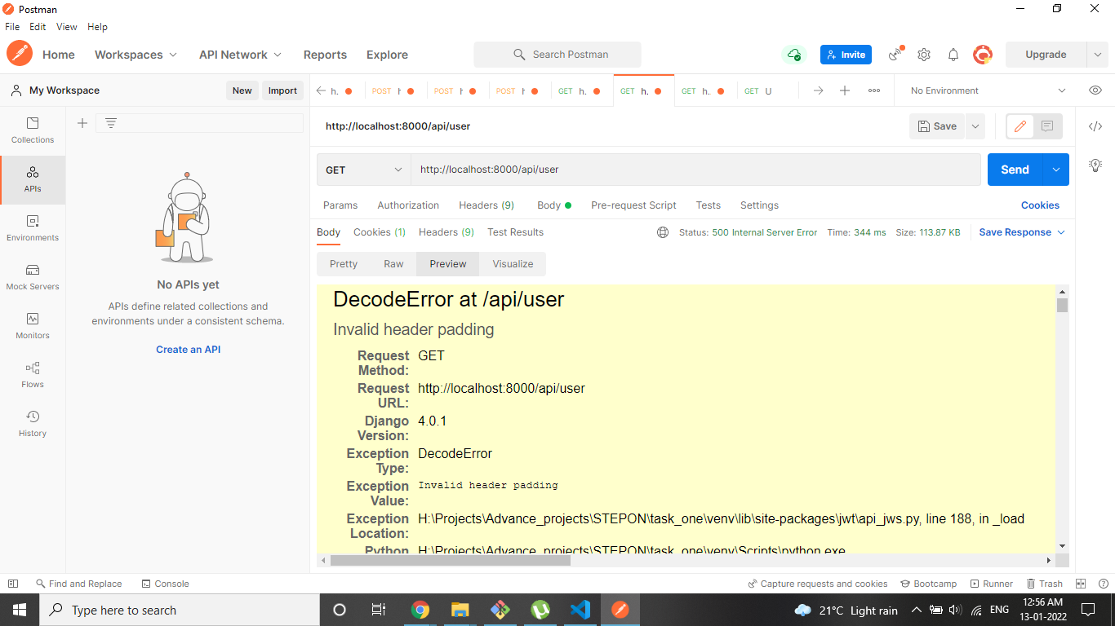

When I am trying to fetch the user id or user name to update the information:

